**Human Computer Interaction DA2**

**Name:** Gotam Sai Varshith

**Reg. No:** 22BCE1605

**Proposed Work: An Adaptive Neuro-Haptic Interface for VR (ANHIVR)**

The literature survey reveals a significant trade-off in Virtual Reality interaction design: the high immersion and naturalness of hand-tracking gestures versus the reliability and precision of physical controllers. Hand-tracking can suffer from tracking errors, leading to user frustration, while controllers can reduce the sense of presence. Furthermore, research shows that cognitive conflict and user frustration can be measured objectively using neurophysiological signals like Feedback-Related Negativity (FRN) from EEG data.

My proposed work is an **Adaptive Neuro-Haptic Interface for VR (ANHIVR)**. This system aims to merge the benefits of both interaction paradigms by dynamically adapting the control scheme based on the user's real-time cognitive state. It will use EEG to detect cognitive conflict when a user struggles with a task using hand-tracking and will adapt the interface to offer more precision, thereby optimizing the user experience by balancing immersion and usability.

**1. Architectural Diagram**

The proposed ANHIVR system is designed as a closed-loop system that constantly monitors the user and adapts the interface.

**System Components:**

1. **Input Layer:**
   * **Hand Tracking Sensor:** A Leap Motion or integrated headset camera to capture hand and finger movements for gesture-based interaction.
   * **EEG Headset:** A non-invasive EEG device to capture brainwave data, specifically to isolate the FRN signal.
   * **VR Controllers:** Standard controllers (e.g., HTC Vive) for high-precision tasks and providing haptic feedback.
2. **Processing Core (ANHIVR Engine):**
   * **Data Acquisition Module:** Collects and synchronizes data streams from the hand tracker, EEG headset, and controllers.
   * **EEG Processing Module:** Filters raw EEG data and applies an algorithm to detect FRN events in real-time. An FRN spike indicates that the outcome of an action was worse than expected, signaling user error or frustration.
   * **Cognitive State Classifier:** An algorithm that analyzes the frequency and amplitude of FRN events. If a predefined threshold of cognitive conflict is crossed, it signals the need for an interface adaptation.
   * **Adaptive Control Logic:** This is the core decision-making algorithm. Based on the output from the Cognitive State Classifier, it decides whether to switch the interaction mode.
   * **Interaction Mode Switcher:** The module that executes the change in the VR application. It can switch from pure hand-tracking to a controller-assisted mode (e.g., by displaying a virtual controller mapped to the hand) or prompt the user to use the physical controller.
3. **Output Layer (VR Application):**
   * **Visual Feedback:** The user sees the virtual environment and their hands or virtual controllers. The system provides visual cues when the interaction mode is about to change.
   * **Haptic Feedback:** The physical controllers provide tactile feedback for actions, confirming successful interactions, which is often missing in pure hand-tracking.
   * **Adaptive UI:** The user interface itself adapts. For example, precision-demanding UI elements might become larger or "snap" to the user's hand position when cognitive conflict is detected.

**Diagram Flow:**

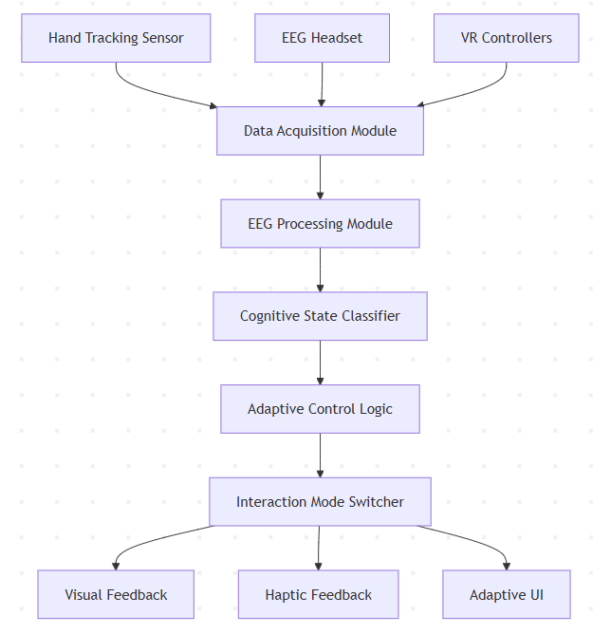

**2. Methodology**

To evaluate the effectiveness of the ANHIVR system, a within-subject user study will be conducted, similar to the methodology used by Capece et al..

* **Participants:** 30 volunteers with prior experience in VR to minimize novelty effects.
* **Apparatus:** A VR system (e.g., HTC Vive), a Leap Motion sensor for hand tracking, a commercial EEG headset, and the custom-built ANHIVR software.
* **Experimental Task:** A complex task involving both broad navigation and fine-grained object manipulation. For instance, a virtual "engine assembly" task where users must first navigate to a workbench and then assemble small parts.
* **Conditions:** Each participant will perform the task under three different interaction conditions:
  1. **Controller-Only:** Traditional interaction using standard VR controllers.
  2. **Hand-Tracking-Only:** Interaction using only bare-hand gestures.
  3. **Adaptive (ANHIVR):** The proposed system that starts with hand-tracking and adaptively assists the user based on detected cognitive conflict.
* **Data Collection & Performance Metrics:**
  1. **Objective Metrics:** Task completion time, number of errors (e.g., dropped parts), and FRN amplitude.
  2. **Subjective Metrics:** Post-task questionnaires to measure:
     + **System Usability Scale (SUS):** To assess overall usability.
     + **Immersion & Usefulness:** Using a Likert scale questionnaire, similar to the one used by Capece et al..
     + **Cognitive Load:** NASA-TLX or a similar subjective workload assessment tool.

**3. Proposed Algorithm**

The core of the proposed work is the **Adaptive Control Logic Algorithm**.

**Objective:** To minimize cognitive conflict and improve task performance by switching from an immersive but error-prone interaction mode (hand-tracking) to a precise one (controller-assisted) when the user struggles.

**Algorithm Steps:**

1. **Initialization:** The system starts in the default Hand-Tracking mode. A cognitive_conflict_score is initialized to 0.
2. **Real-time Monitoring:** In a continuous loop: a. Acquire synchronized data from EEG and hand-tracking sensors. b. Process the EEG stream to detect FRN event amplitudes following user actions (e.g., grabbing an object).
3. **Conflict Detection:** a. If an FRN event is detected with an amplitude (A_frn) exceeding a pre-calibrated baseline threshold (T_base), update the cognitive_conflict_score:

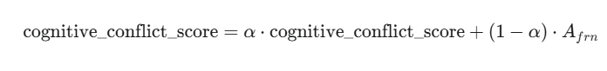​

(where alpha is a decay factor to give more weight to recent events). b. If no significant FRN is detected, slowly decay the score over time.

1. **Mode Intervention:** a. If cognitive_conflict_score > T_{switch_high} (a high conflict threshold): i. Transition the system state to Controller-Assisted mode. ii. Render a virtual controller model over the user's hand or prompt the user to pick up the physical controller. iii. Remap hand gestures to precise actions (e.g., pinch becomes a button press).
2. **Reversion to Immersive Mode:** a. If the system is in Controller-Assisted mode AND cognitive_conflict_score < T_{switch_low} (a low conflict threshold) for a sustained period: i. Transition the system back to Hand-Tracking mode. ii. Fade out the virtual controller visuals.

This algorithm ensures the system only intervenes when necessary, preserving the immersive quality of hand-tracking for as long as possible while providing support to prevent excessive user frustration.

**4. Comparison Table: Proposed Work vs. Literature Survey**

|  |  |  |  |
| --- | --- | --- | --- |
| Reference | Methodology | Algorithm(s) Used | Performance Metrics |
| Selzer & Castro (2022): Immersion Metrics for VR | Collected experimental data from VR setups and performed regression analysis to identify predictors of immersion. | Multivariate regression modelling | Regression accuracy (R²), variable contribution weights, validation error |
| Capece et al. (2023): Evaluation of VR Interaction Techniques | Within-subject study comparing hand gestures vs controllers in HMD and spherical display environments. | Gesture recognition, 6-DOF controller processing | Immersion level, ease of use, usefulness, behavioral intention (Likert scale) |
| Khundam et al. (2020): VR Training Interaction Study | Quasi-experimental study with medical trainees using VR for intubation training. | Compared hand-tracking gesture recognition vs controller input mapping | Task time, SUS, USEQ (usefulness, ease of use, learning, satisfaction) |
| Singh et al. (2017): Measuring Cognitive Conflict in VR | Two-phase study with EEG sensors and tracked-hand object selection. Manipulated selection radii to trigger cognitive conflict. | EEG signal processing, FRN extraction | FRN amplitude, error rate, response time, subjective comfort |
| Chen et al. (2024): Survey on VR Interaction Interfaces | Systematic literature review of 438 papers categorized by interaction types and evaluation methods. | Not applicable (qualitative analysis) | Task completion time, usability scores, error rates, subjective experience scores |